Mohammed Al Madhi

CIS -310 FINAL

47.

**Membership table SQL Query.**

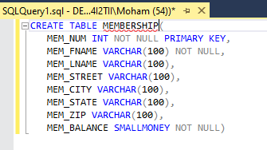

**RENTAL Table SQL Query**

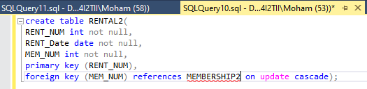

**Price Table SQL Query**

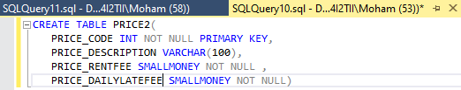

**Movie Table SQL Query**

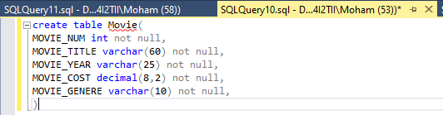

**Video Table SQL Query**

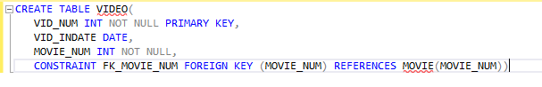

**Rental Table SQL Query**

create table Detail_RENTAL(

VID_NUM int not null,

DETAIL_FEE decimal(8,2) not null,

DETAIL_DUEDATE date not null,

DETAIL_RETURNDATE date,

DETIAL_DAILY_LATE_FEE decimal(8,2) ,

primary key (RENT_NUM, VID_NUM),

foreign key(RENT_NUM) references RENTAL on update cascade,

foreign key(VID_NUM) references Video on update cascade);

48.

**Inserting Values to the Membership Table**

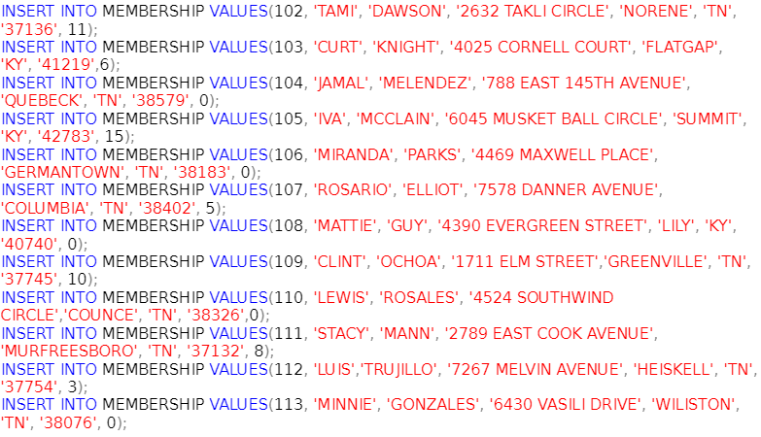

**Inserting Values to the Detail Rental Table**

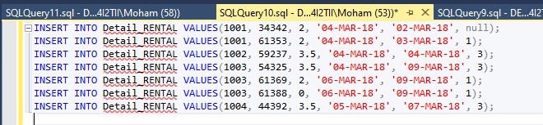

**Inserting Values into Video Table**

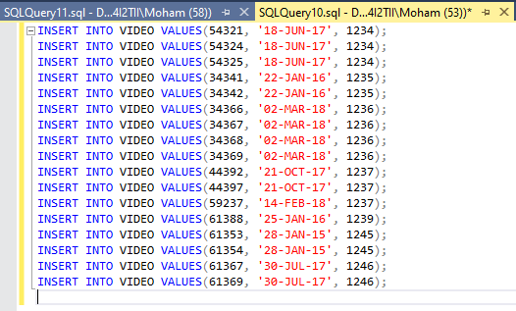



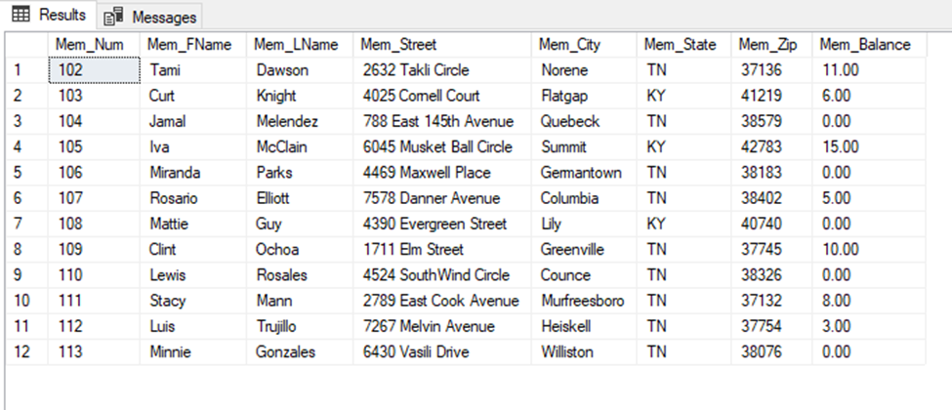

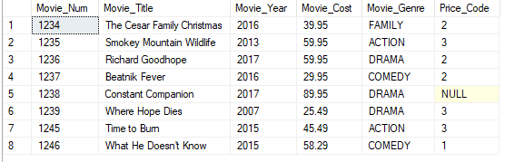

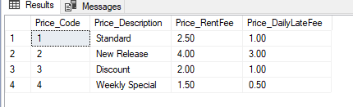

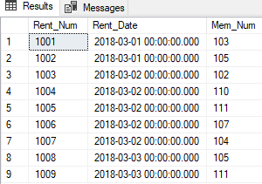

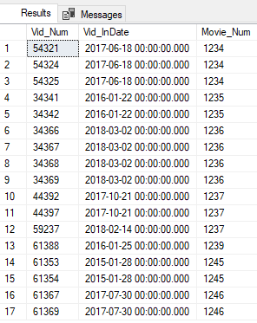

**49**.

UPDATE MOVIE

SET MOVIE_YEAR = 2014

WHERE MOVIE_NUM = 1245;

**50**.

UPDATE MOVIE

SET PRICE_CODE = 3

WHERE MOVIE_GENRE = 'ACTION';

**51.**

UPDATE PRICE

SET PRICE_RENTFEE = PRICE_RENTFEE + .5;

**Relational Diagram based on the given ERD on page 433.**

